**AIM:** Write a C program to Graph traversal using Breadth First Search

**ALGORITHM:**

• Start from a given source vertex.

• Mark the source vertex as visited and enqueue it.

• While the queue is not empty:

* Dequeue a vertex.
* Visit all its adjacent (unvisited) vertices.
* Mark them as visited and enqueue them.

• Continue until all reachable vertices are visited.

**CODE:**

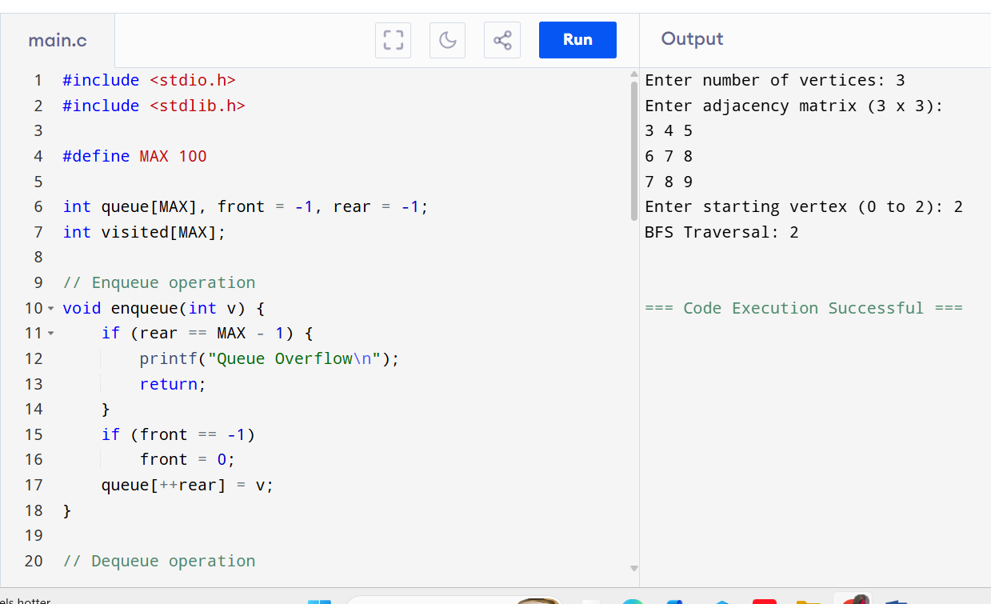

**OUTPUT:**

Enter number of vertices: 3

Enter adjacency matrix (3 x 3):

3 4 5

6 7 8

7 8 9

Enter starting vertex (0 to 2): 2

BFS Traversal: 2